MAJOR PROJECT
Attack, Detect & Secure the Environment

Project Title:
Attack, Detection, and Hardening of a Cloud-Based Enterprise Environment

Course: B. Tech – Cyber Security (5th Semester)
Subject: Cyber Security Lab / SOC Operations
Submitted By: Khushi Mahato (teamed with Minakshi Sinha)
Institution: Rungta College of Engineering & Technology, Bhilai
Academic Year: 2025–26

1. ABSTRACT

This project presents a practical implementation of attack simulation, detection, investigation, and security hardening in a cloud-based enterprise environment. A vulnerable infrastructure was deployed on Microsoft Azure to simulate a real-world organization. Various cyber-attacks were performed to generate security events, which were analysed using system and application logs. Based on the investigation, multiple security misconfigurations were identified and remediated through hardening techniques. The effectiveness of the applied security controls was validated by re-performing the same attacks and comparing system behaviour before and after hardening.

2. INTRODUCTION

Cloud computing has become an integral part of modern enterprises, but misconfigured cloud resources are a major cause of security breaches. Organizations rely on Security Operations Centres (SOC) to detect, analyse, and respond to cyber threats. This project aims to provide hands-on experience in both Red Team (attack simulation) and Blue Team (defensive security) operations by implementing a complete attack–detect–secure lifecycle in a controlled environment.

3. PROBLEM STATEMENT

Many cloud-based systems suffer from weak authentication mechanisms, exposed services, a lack of monitoring, and an absence of security hardening. These weaknesses allow attackers to exploit systems easily. The challenge is to simulate realistic cyber-attacks, detect malicious activity using logs, identify misconfigurations, apply appropriate security hardening, and validate the improved security posture.

4. OBJECTIVES

To deploy a cloud-based enterprise infrastructure
To simulate real-world cyber-attacks
To generate and analyse security logs
To identify vulnerabilities and misconfigurations
To apply security hardening measures
To validate security improvements through re-attack

5. SYSTEM ARCHITECTURE & INFRASTRUCTURE
5.1 Infrastructure Overview
VM Role Purpose
VM1 Internal Server Identity & internal services
VM2 Web Server (DMZ) Attack target
VM3 SIEM / Analyst Log monitoring

5.2 Network Design
Azure Virtual Network (VNet)
Internal Subnet → VM1, VM3
DMZ Subnet → VM
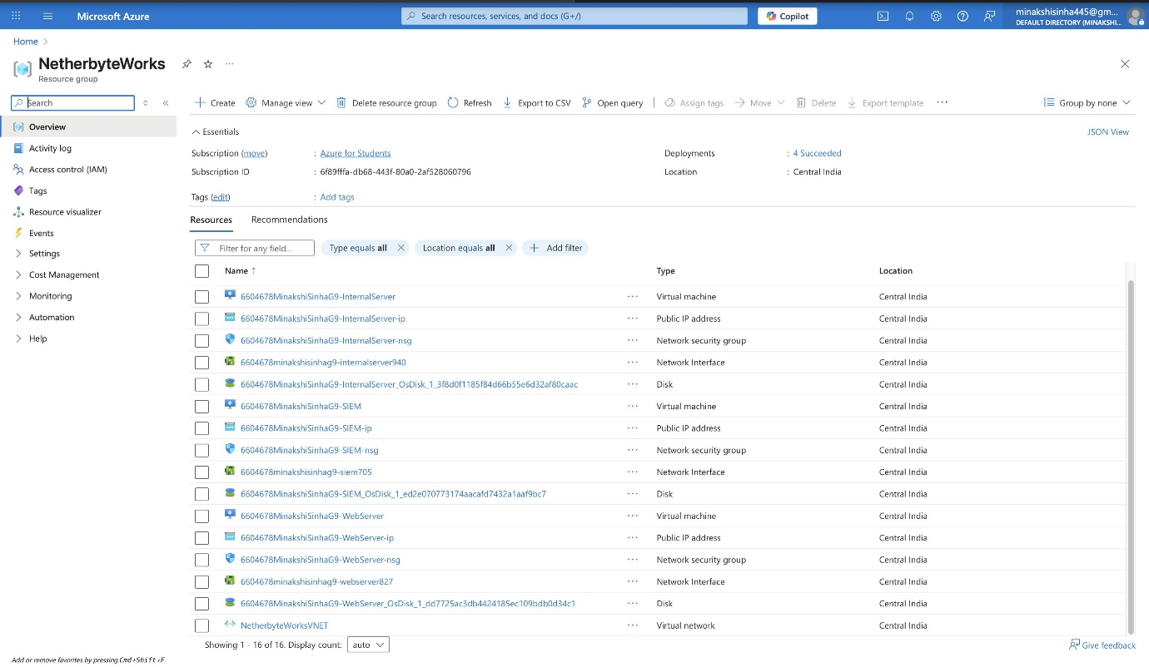

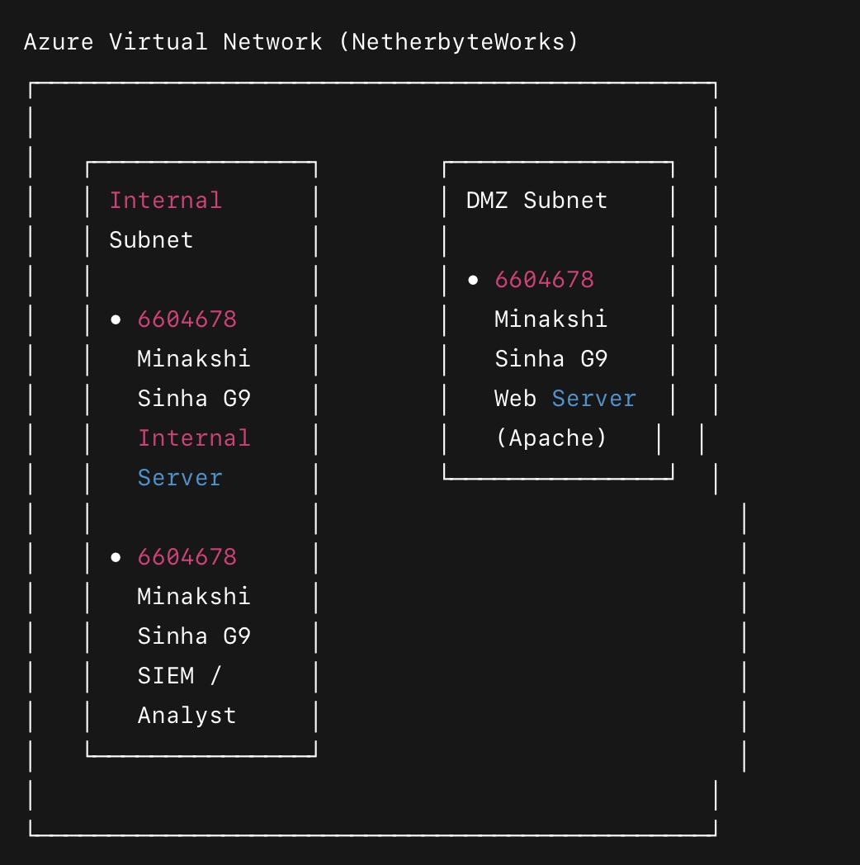

6. RED TEAM – ATTACK SIMULATION (PHASE 1)
The following attacks were performed on the Web Server (VM2):
6.1 SSH Brute Force Attack
Multiple invalid login attempts using non-existent users
Logs generated in /var/log/auth.log

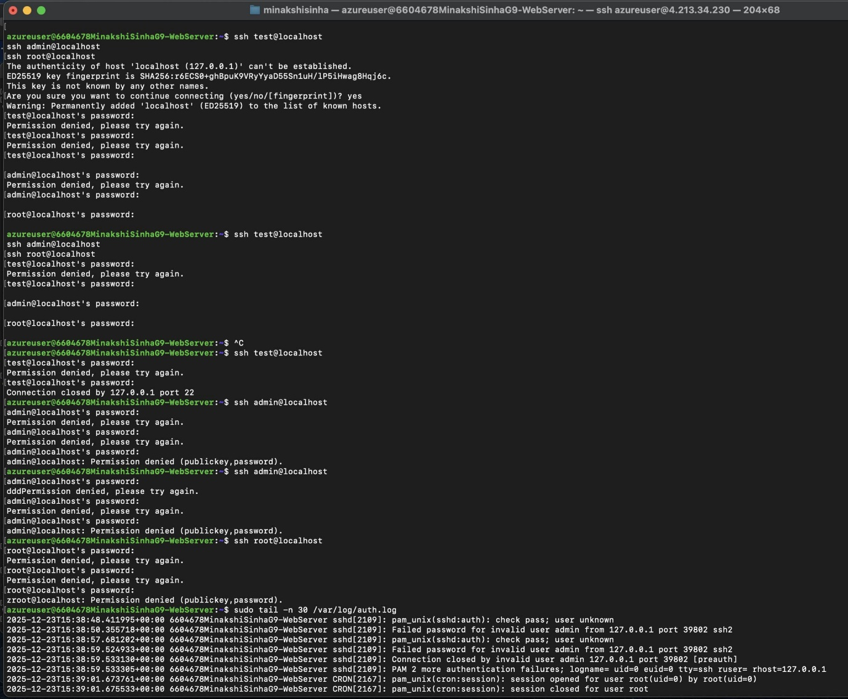

6.2 Directory Traversal Attack
Attempted access to sensitive system files using manipulated URLs
Requests logged in Apache access logs

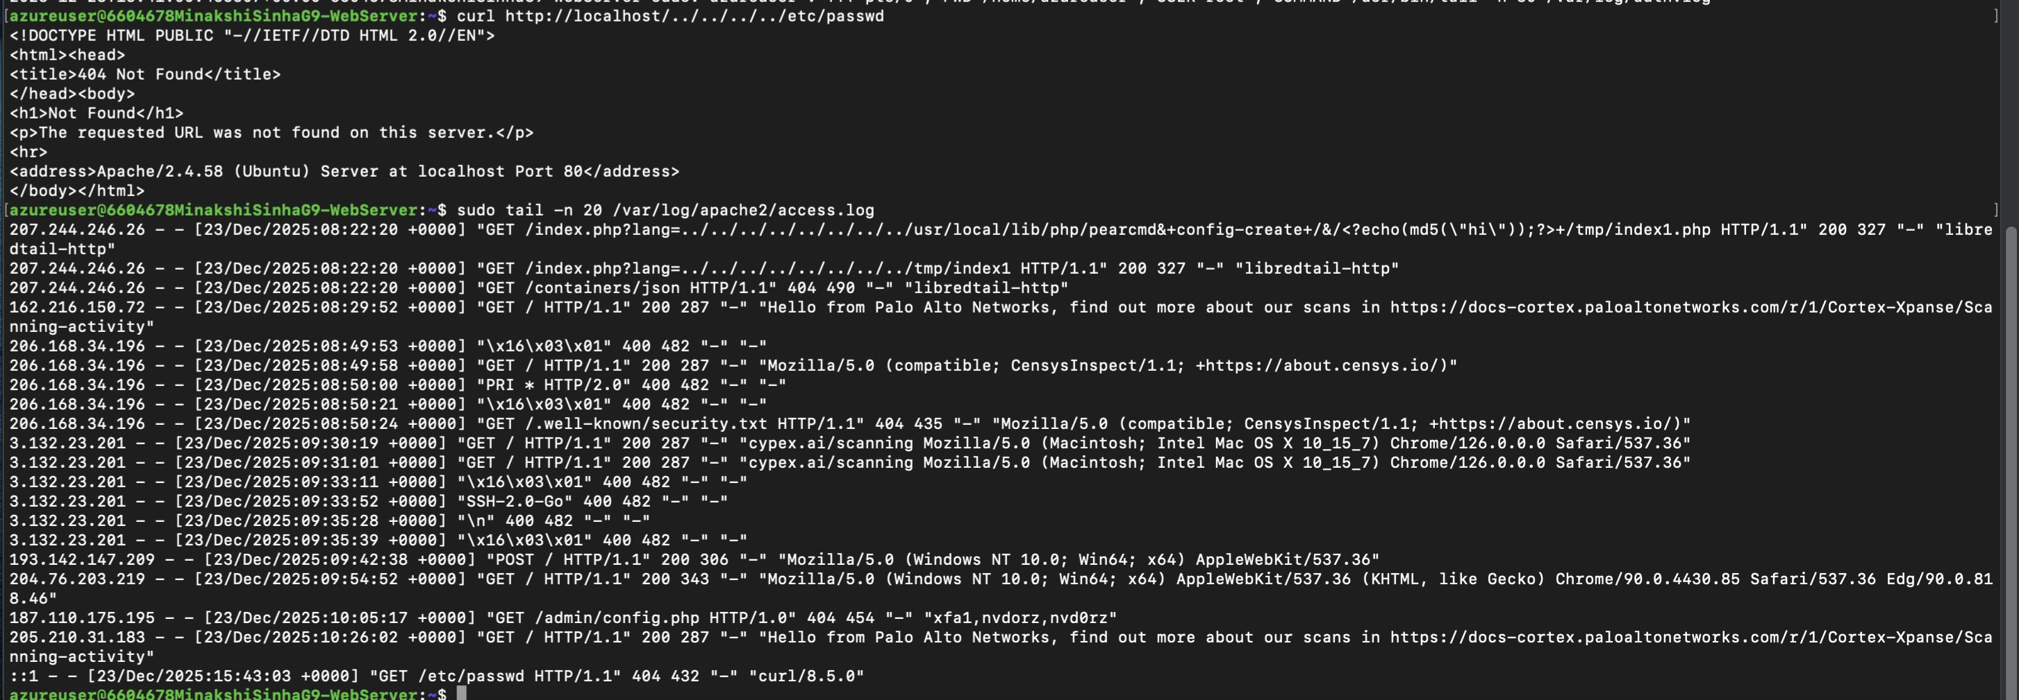
6.3 Port Scanning
Open ports and services identified using Nmap
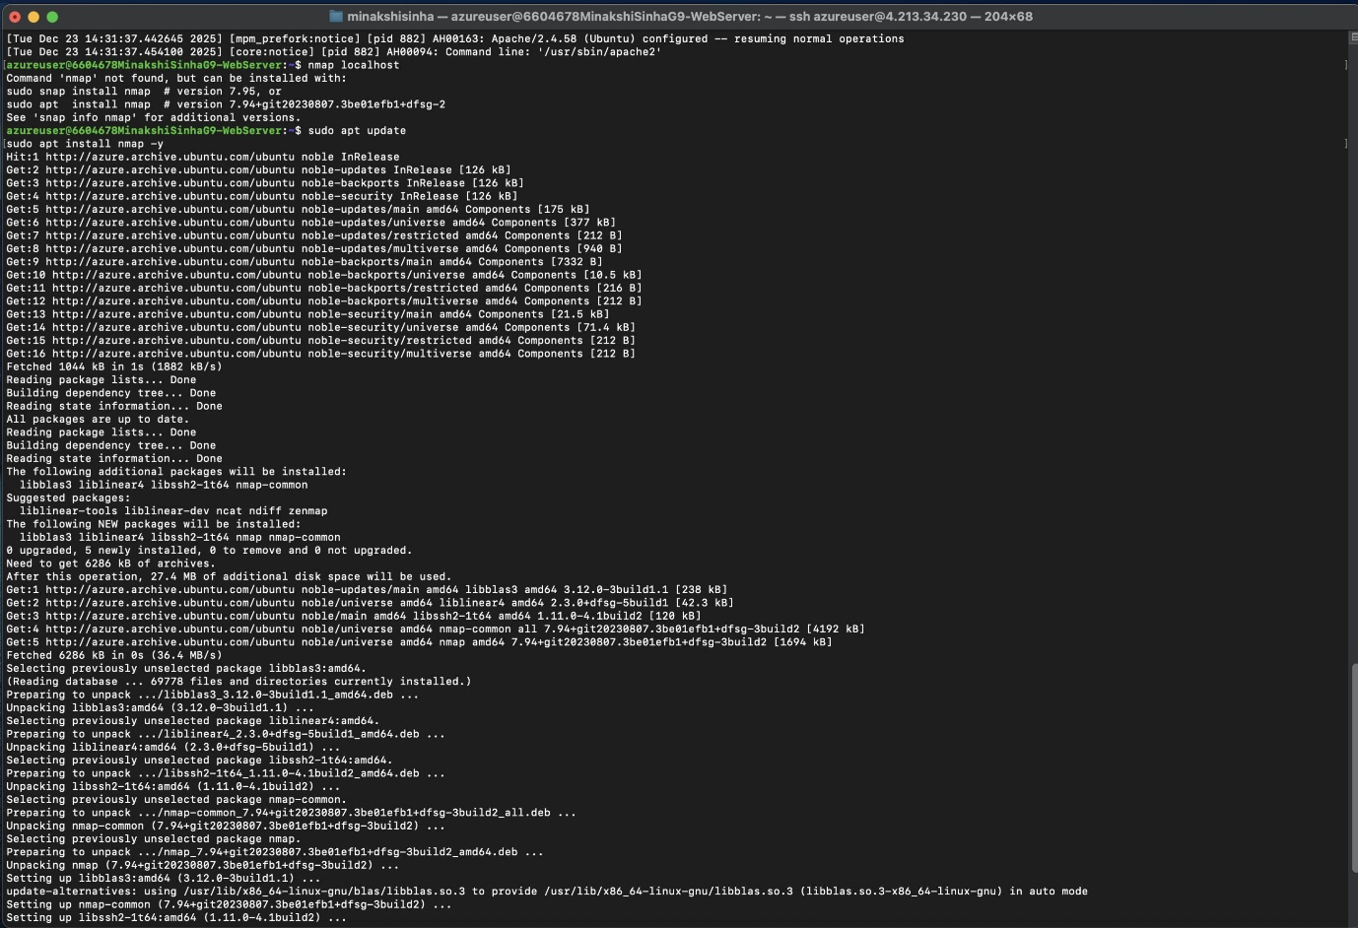

7. BLUE TEAM – INVESTIGATION & LOG ANALYSIS (PHASE 2)
7.1 Logs Analysed
Authentication logs (auth.log)
Apache access logs
Apache error logs

7.2 Indicators of Compromise (IOC)
Indicator Type Value
Attacker IP 127.0.0.1
Attack Types SSH brute force, Directory traversal
Tools Used SSH, curl, Nmap
Target Services SSH, Apache
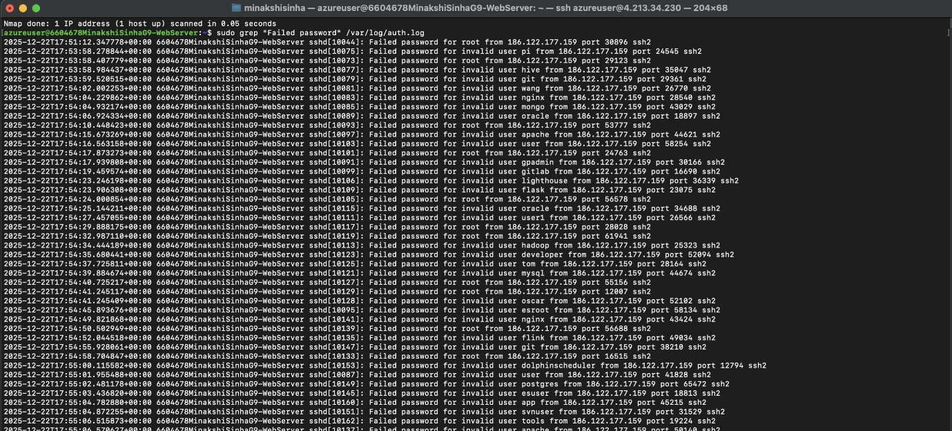

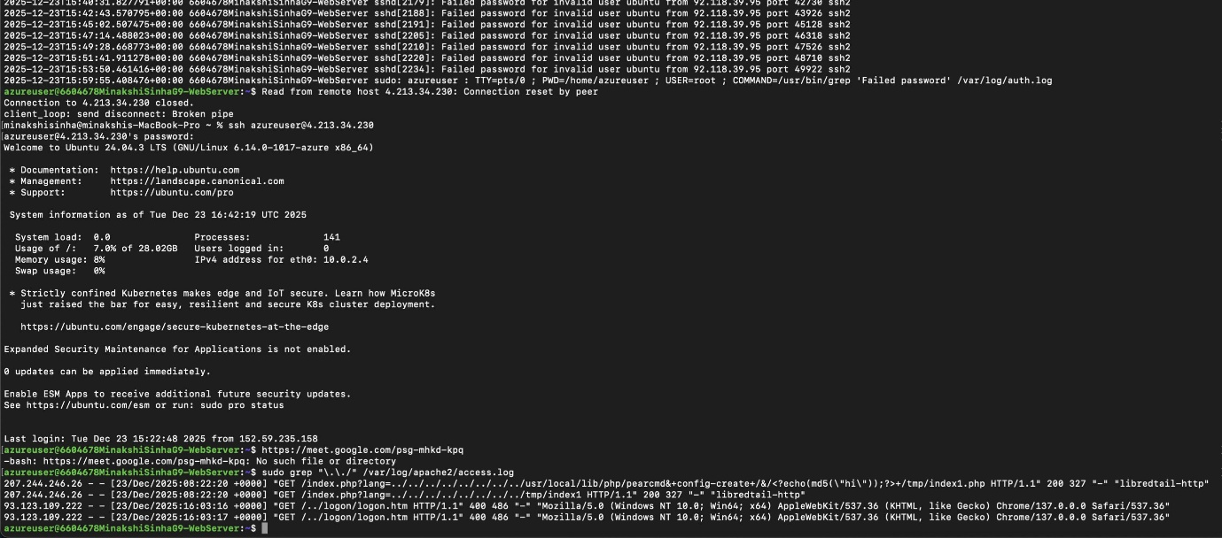

8. MISCONFIGURATIONS IDENTIFIED
Password-based SSH authentication enabled
No firewall rules applied
Apache server information disclosure
Excessive file permissions
9. SECURITY HARDENING (PHASE 3)
Based on the investigation, the following security measures were implemented:
9.1 SSH Hardening
Root login disabled
Password authentication disabled
9.2 Firewall Configuration
UFW enabled
Only SSH and HTTP are allowed
9.3 Web Server Hardening
Apache server tokens hidden
Server signature disabled
9.4 File Permission Hardening
Least privilege applied to web directories

- SSH configuration and service status
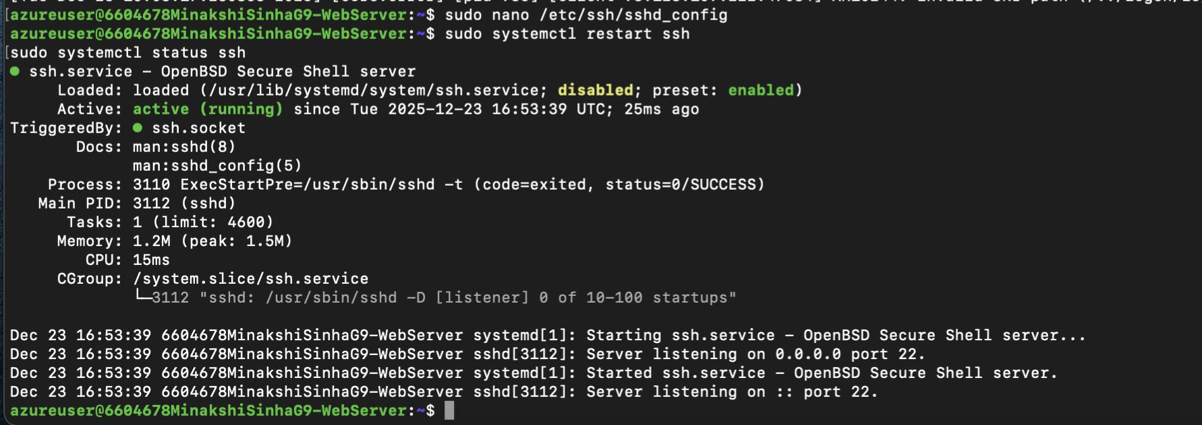
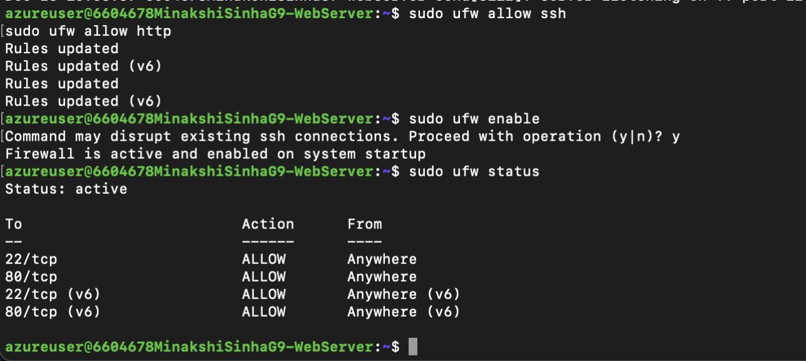
- Firewall (UFW) active status

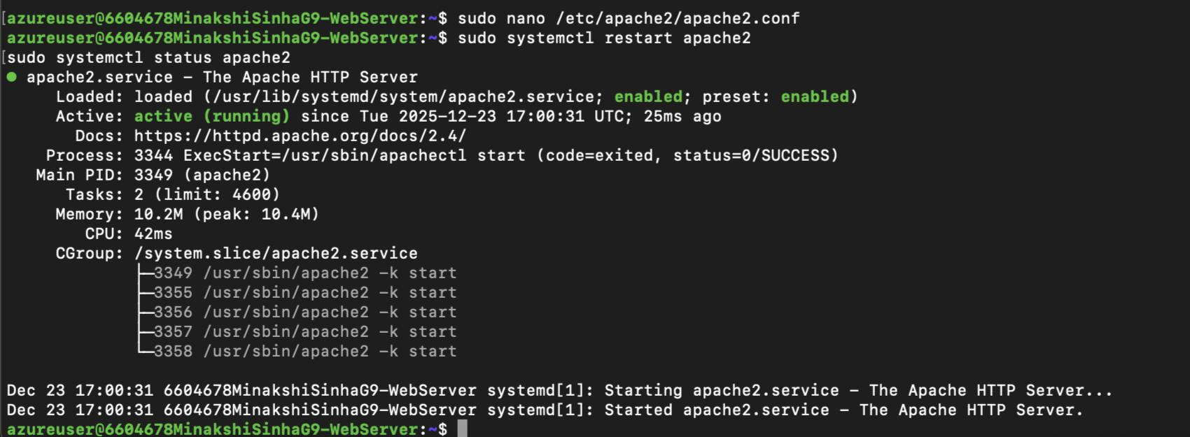
- Apache hardened configuration

10. RE-ATTACK & VALIDATION (PHASE 4)
The same attacks were repeated after hardening.
Observations:
- SSH brute-force attempts blocked
- Directory traversal denied
- Reduced attack surface
- Cleaner and controlled logs
- Before vs After Comparison
Parameter Before Hardening After Hardening
SSH Vulnerable Secured
Firewall Disabled Enabled
Apache Info disclosed Hidden
Logs Noisy Controlled

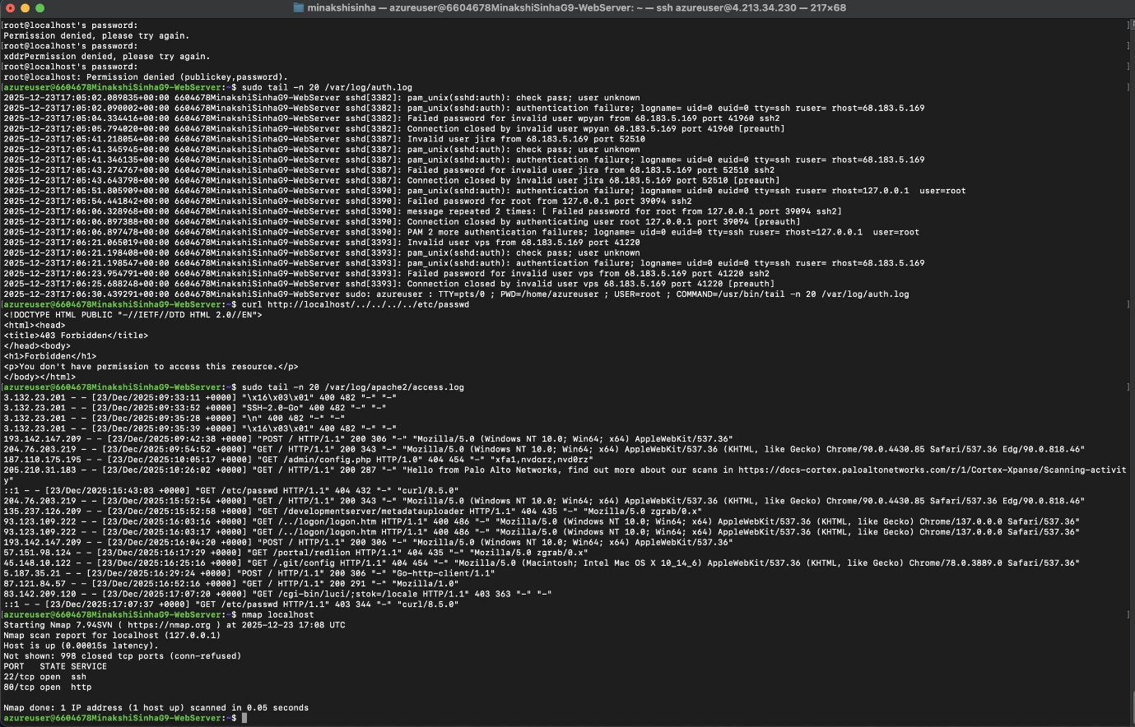

11. FINAL SECURITY POSTURE
The system demonstrated a significantly improved security posture after hardening. Attack attempts were either blocked or limited, and logs reflected effective detection and response mechanisms.

12. CONCLUSION
This project successfully demonstrated real-world cyber-attack simulation, detection through log analysis, vulnerability identification, security hardening, and validation. The hands-on experience provided practical exposure to SOC-level operations and defensive security strategies.

> REFERENCES
Linux System Administration Documentation
Apache Security Guide
Azure Virtual Machine Documentation
SIEM and SOC Fundamentals

